PATUAKHALI SCIENCE AND TECHNOLOGY UNIVERSITY

**Assignment Name: Lab Problem 17**

**Course Code: CCE-314**

**Course Title: Computer Networks Sessional**

Submitted to:

**Dr. Md. Samsuzzaman**

Professor

Department of Computer and Communication Engineering

Faculty of Computer Science and Engineering

Submitted by:

**Arfan Ahmed**

ID No.: 2002040

Registration No.: 09557

Level-3, Semester-1, Session: 2020-2021

Faculty of Computer Science & Engineering

Date of Submission: July 03, 2024

**10.7.1: Skills Integration Challenge-Network Planning and Interface Configuration**

# Topology Diagram

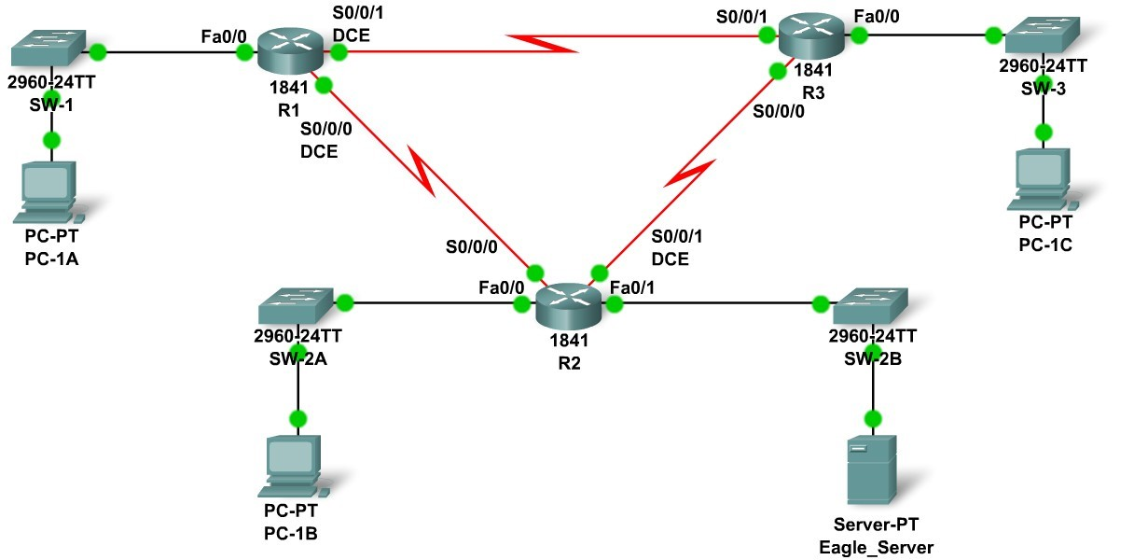

# Addressing Table

|  |  |  |  |  |
| --- | --- | --- | --- | --- |
| **Device** | **Interface** | **IP Address** | **Subnet Mask** | **Default Gateway** |
| **R1** | **Fa0/0** | **192.168.1.62** | **255.255.255.192** | **N/A** |
| **S0/0/0** | **192.168.1.129** | **255.255.255.252** | **N/A** |
| **S0/0/1** | **192.168.1.133** | **255.255.255.252** | **N/A** |
| **R2** | **Fa0/0** | **192.168.1.110** | **255.255.255.240** | **N/A** |
| **Fa0/1** | **192.168.1.94** | **255.255.255.224** | **N/A** |
| **S0/0/0** | **192.168.1.130** | **255.255.255.252** | **N/A** |
| **S0/0/1** | **192.168.1.137** | **255.255.255.252** | **N/A** |
| **R3** | **Fa0/0** | **192.168.1.126** | **255.255.255.240** | **N/A** |
| **S0/0/0** | **192.168.1.138** | **255.255.255.252** | **N/A** |
| **S0/0/1** | **192.168.1.134** | **255.255.255.252** | **N/A** |
| **PC-1A** | **NIC** | **192.168.1.1** | **255.255.255.192** | **192.168.1.62** |
| **PC-1B** | **NIC** | **192.168.1.97** | **255.255.255.240** | **192.168.1.110** |
| **PC-1C** | **NIC** | **192.168.1.113** | **255.255.255.240** | **192.168.1.126** |
| **Eagle_Server** | **NIC** | **192.168.1.93** | **255.255.255.224** | **192.168.1.94** |

# Learning Objectives

Upon completion of this lab, you will be able to:

* Build the network topology
* Plan the IP addresses
* Configure router and PC interfaces
* Test the network

# Background

Practice your network building, planning, and configuration skills. Device names and routing have already been configured.

**Task 1: Build the Network Topology.**

Use the following charts, and the devices in the Device Pool, to create the topology.

**Routers:**

|  |  |  |  |
| --- | --- | --- | --- |
| **Hostname** | **Interface** | **Connects To** | **Interface** |
| R1 | Fa0/0 | SW-1 | Fa0/1 |
| R1 | S0/0/0 (DCE) | R2 | S0/0/0 |
| R1 | S0/0/1 (DCE) | R3 | S0/0/1 |
| R2 | Fa0/0 | SW-2A | Fa0/1 |
| R2 | S0/0/1 (DCE) | R3 | S0/0/0 |
| R2 | Fa0/1 | SW-2B | Fa0/1 |
| R3 | Fa0/0 | SW-3 | Fa0/1 |

**Switches:**

|  |  |  |  |
| --- | --- | --- | --- |
| **Hostname** | **Interface** | **Connects To** | **Interface** |
| SW-1 | Fa0/2 | PC-1A | FastEthernet |
| SW-2A | Fa0/2 | PC-1B | FastEthernet |
| SW-2B | Fa0/2 | Eagle_Server | FastEthernet |
| SW-3 | Fa0/2 | PC-1C | FastEthernet |

**Task 2: Create and Assign an Addressing Scheme.**

You are asked to use the 192.168.1.0 /24 address space. Seven total networks are required; assign the networks in decreasing order of number of hosts required for efficient use of address space. Use the following charts to create an effective addressing scheme:

**LAN:**

|  |  |  |
| --- | --- | --- |
| **Hostname** | **Interface** | **Number of Hosts** |
| R1 | Fa0/0 | 60 |
| R2 | Fa0/0 | 10 |
| Fa0/1 | 25 |
| R3 | Fa0/0 | 7 |

**WAN:**

|  |  |  |
| --- | --- | --- |
| **Hostname** | **Address to be Assigned** | **Number of Hosts** |
| R1-R2 | R1-First host address | 2 |
| R1-R3 | R1-First host address | 2 |
| R2-R3 | R2-First host address | 2 |

Use the following rules to assign the IP addresses.

* PC's will use the first host address in the subnet.
* Tthe server will use the second to last host address in its subnet.
* All FastEthernet ports on a router will use the last host address of the assigned subnet.
* The R1-R2 link will use the first WAN subnet, with R1 using the first usable address and R2 using the last usable adress.
* The R1-R3 link will use the second WAN subnet, with R1 using the first usable address and R3 using the last usable address.
* The R2-R3 link will use the third WAN subnet, with R2 using the first usable address and R3 using the last usable address.
* DCE interfaces should have clock rates of 56000.

# Task 3: Interface Configuration

Perform interface configuration of the R1, R2, and R3 routers, the PCs, and the server according to the addressing scheme above.

# Task 4: Testing Connectivity

Make sure all PCs can ping their gateways, other PCs, and the server.